weekly journal evidence

Task assignment:

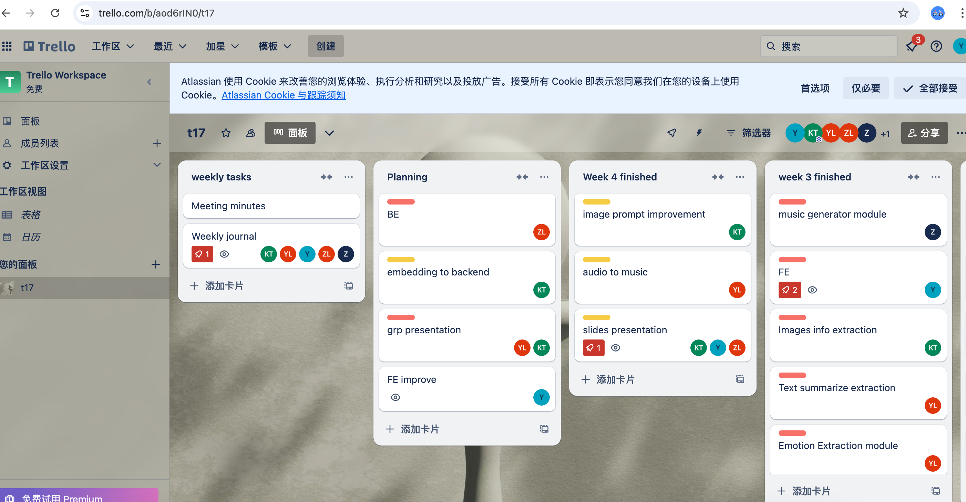

Add the play bar of BGM:

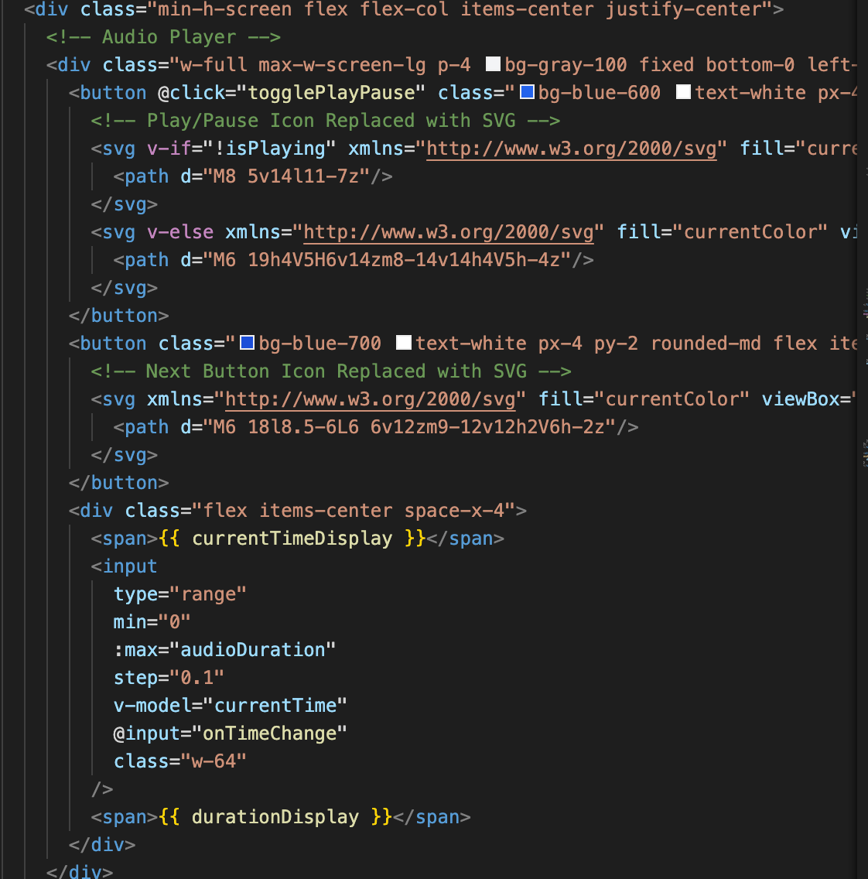

The outcome of playing bar:

